Successful compilation and execution:

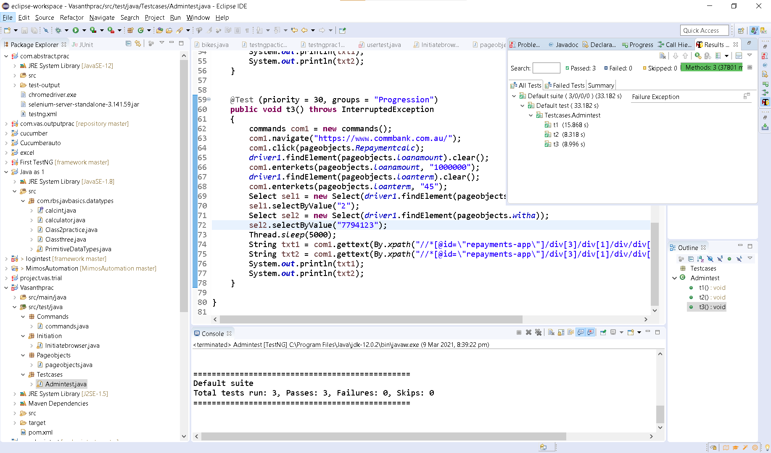

Screenshots of printed output:

